39.43: a) Recall 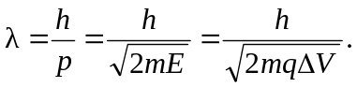So for an electron:
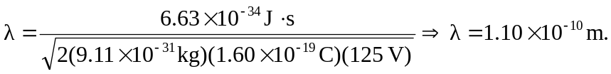
b) For an alpha particle:
